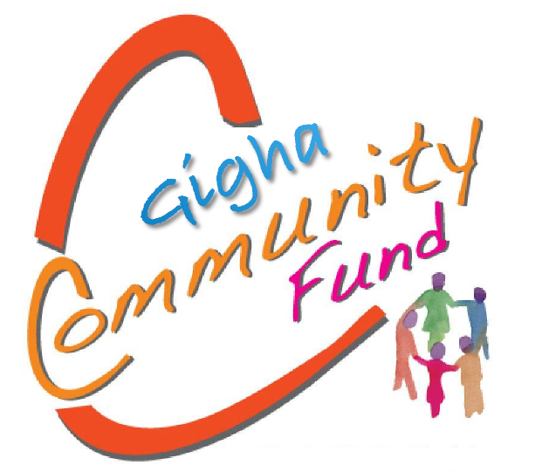

‘to support a thriving and healthy community on Gigha’
Guidance Notes for grants up to £1000
www.gigha.org.uk

The Isle of Gigha Heritage Trust was incorporated in October 2001. The objects for which the Company is established are:

“To promote the benefit of the inhabitants of the Community, without distinction on grounds of race, political, religious or other opinions, by associating with the local statutory authorities, voluntary organisations and inhabitants in a common effort to advance education and to provide or assist in providing facilities for recreation and other leisure-time occupation following principles of sustainable development and in the interests of social welfare so that their conditions of life may be improved, where ‘sustainable development’ means development which meets the need of the present without compromising the ability of future generations to meet their own needs.

To promote for the public benefit rural regeneration, following principles of sustainable development, where ‘sustainable development’ means development which meets the need of the present without compromising the ability of future generations to meet their own needs, in areas of social and economic deprivation within the Community”
The Isle of Gigha Heritage Trust (IGHT) through its subsidiary company Gigha Renewable Energy Limited (GREL), are offering grants to community projects through its Gigha Community Fund (GCF). The aim of the funding programme is to support organisations, groups and individuals to develop, thrive and grow; therefore, further supporting future sustainability and community resilience.
The fund has been established from the income from GREL and launched in December 2019.
GCF offers small grants to applications up to a maximum of £1,000. There is £5,000 available over a 12 month period 1st of April to 31st March.
Grant awards will normally be made on evidence of costs being incurred unless payment is required in advance of incurring costs and this is approved by the Fund Board at time of application. Applicants will be expected to provide a project completion form once the project is completed.
These grants are not made up of public funds and therefore are not restricted.
The Gigha Community Fund logo is to be provided to successful applicants to allow them to acknowledge the fund on their project promotion and associated paperwork.
What can the Grant be used for?
This grants programme is for organisations, individuals and groups that provide or seek to provide activities or services that focus on any of the objectives outlined below.

We will fund a wide range of community projects aimed at (but not exhaustive to):
developing skills; improving health; relieving poverty; protecting or conserving the environment; engaging citizens to become more active in the community; promoting and protecting the rich heritage and culture of the area; and supporting visitor experience.

These are the outcomes that we refer to and you should show in your applications which of these you aim to deliver.

Am I eligible to apply?
Those applying for grants must:
- An individual or community organisation/group
- Be situated / or the beneficiaries of the project will be situated on Gigha
- For organisations, have a constitution or set of rules setting out the organisation’s aims and objectives
- Hold a Bank or building society account in the name of the individual / organisation / group
- Be able to spend the grant within the specified timescale i.e. 6 months from letter of offer. Grant offers may be withdrawn if funds are not spent within 6 months of the date of offer.

How much can I apply for?
This fund is for £1,000 and under. We do not expect applications for below £100. The money should be spent within a 6 month period from letter of offer. Should you/your organisation/group wish to apply to the fund more than once a year, the Fund Board will consider this. However, if applying for a second time, there must be at least 6 months between awards.

How will our application be assessed?
Grants must have clear and measurable outcomes that meet the objectives of the Gigha Community Fund. Organisations should ensure they can answer yes to at least one of the statements below.

My project/activities will have clear outcomes and will seek to:
- Develop skills
- Improve health
- Relieve poverty
- Protect or conserve the environment
- Engage citizens to become more active in their community
- Promote and protect the rich heritage and culture of the area
- Supporting visitor experience

Applications will be assessed by Fund Board.

Is there anything that will not be funded?

GCF will not fund:

- projects or activities that do not meet any of the objectives outlined
- VAT that can be recovered by the applicant
- day to day running costs
- the purchase of alcohol and other unlawful substances
- projects that cannot be completed within 6 months of the date of the grant offer
- projects or activities that the state has a legal obligation to provide
- activities that will have already taken place by the time the decision is made
- items that are purchased on behalf of another organisation
- organisations seeking to boost profit/return
- applicants that have their own resources to undertake the project

What are the deadlines for applications?

Applications will be accepted throughout the year.

How do we apply?

Contact the office either by email or telephone for an application or download an application form from the website www.gigha.org.uk. Contact details are at the end of this form.

What happens to our application?

- We will acknowledge receipt of your application by email if you provided an email address or in writing if not.
- Initial assessments will be undertaken by IGHT staff to confirm you have completed the application correctly and provided all relevant information.
- Decisions on all applications are only taken by the Fund Board, details of who can be found on the Isle of Gigha website.
- We will aim to make a decision within 4 weeks of all required information being submitted and we will write to you as soon as possible to let you know the outcome.
- If a grant has been awarded you will be sent a letter of offer as well as the conditions of your grant, which we will need you to sign and return. We will also require a bank details form to be completed and a bank statement to be enclosed, which will be returned.
- Once receipts/invoices or quotes where applicable* have been received, your grant will be paid directly into your organisation’s bank account via bank transfer.
- All grant recipients are required to complete a project completion form once the grant has been spent.
- If your grant is deferred, it means it will be accepted for consideration but held until the Fund is replenished. The application will then be considered, and we let you know if your application is successful or not. Please note that a deferred application does not mean it will be successful.
- If a grant has not been awarded, you will be able to request feedback and reapply after 6 months.

How does the claims process work? *
Your grant will be paid out in one single payment if you are awarded funding and have provided invoices/receipts as evidence of costs. Evidence of costs being incurred must be provided unless payment is required in advance of incurring costs and this is approved by the Fund Board at time of application. All receipts/invoices should be retained.
We will send you a letter of offer, two copies of our terms and conditions and a bank details form. When they have been signed and one copy has been returned, we will then pay out the grant via bank transfer upon evidence of costs. At the end of your project you will be sent a project completion form which should be completed. We will accept the form and receipts etc. in digital format.

How will the grant be paid out?
We will pay your grant by bank transfer (BACS). The grant can only be paid to the organisation/individual named in the grant notification letter.

Please note that you must have started your project within 3 months of being awarded the funding. If your timescales have changed you must let us know as soon as possible. If the project is not going to go ahead in the agreed timescales, we may seek further clarification to secure the grant. We ask for this as we may be able to use it to support another organisation who are ready at the time. This would not stop you from reapplying when you are ready.

What are the conditions of the grant award?

All organisations awarded a grant must agree to our standard grant conditions. A letter of offer will be sent to organisations if they are awarded a grant, along with a document outlining the conditions of the grant award.

We will ask that you read this document carefully, sign it and return it, keeping one copy for your own records.

If you would like to see a copy of our conditions prior to applying for a grant, please get in touch and we can send them to you.

For more information please visit the website www.gigha.org.uk
Alternatively, you can email: chair@gigha.org.uk or call us on 01583 505 390

